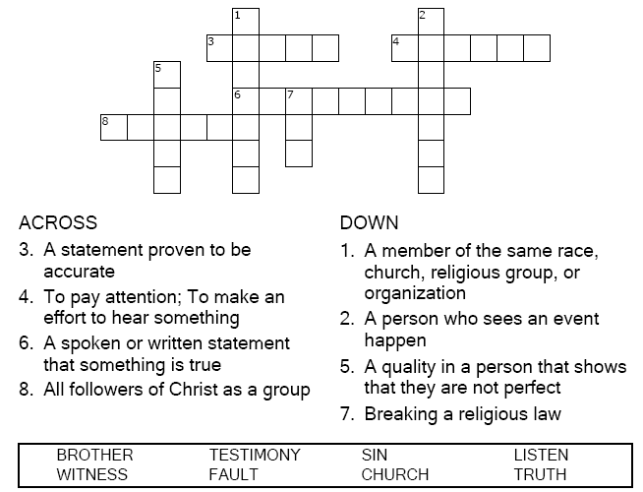


Copyright © Sermons4Kids, Inc.
May be reproduced for Ministry Use

Children’s Worship Bulletin

Building Bridges

Matthew 18:15-20

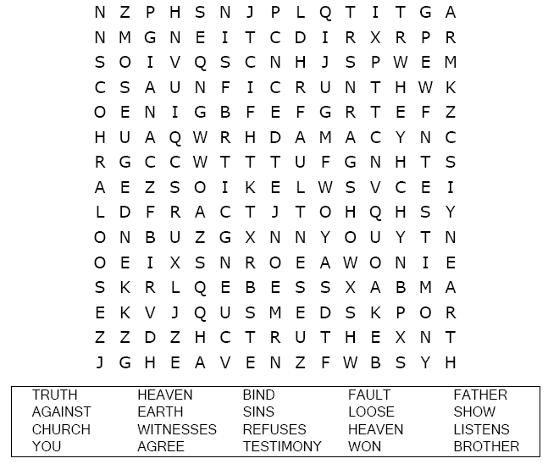
Faith United Methodist Church

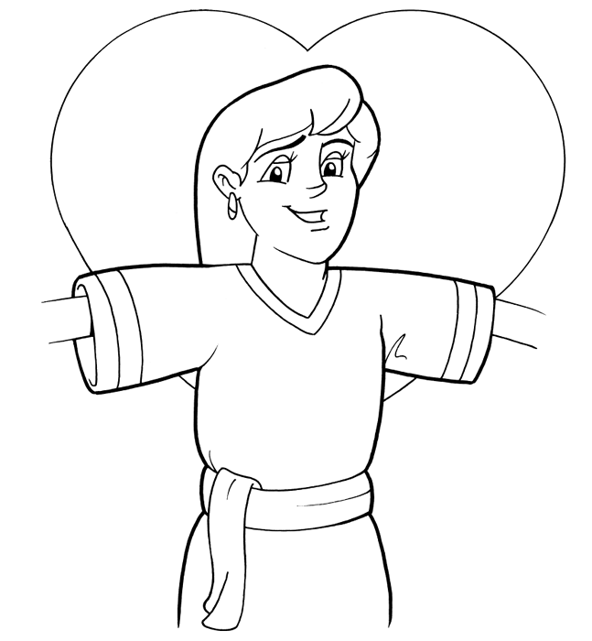
"If a fellow believer hurts you, go and tell him -- work it out
between the two of you. If he listens, you've made a friend."
Matthew 18:15 (NIV)

Copyright © CalvaryCurriculum.com
Used by Permission

Each number represents a letter of the alphabet. Substitute
the correct letter for the numbers to reveal the coded words.

