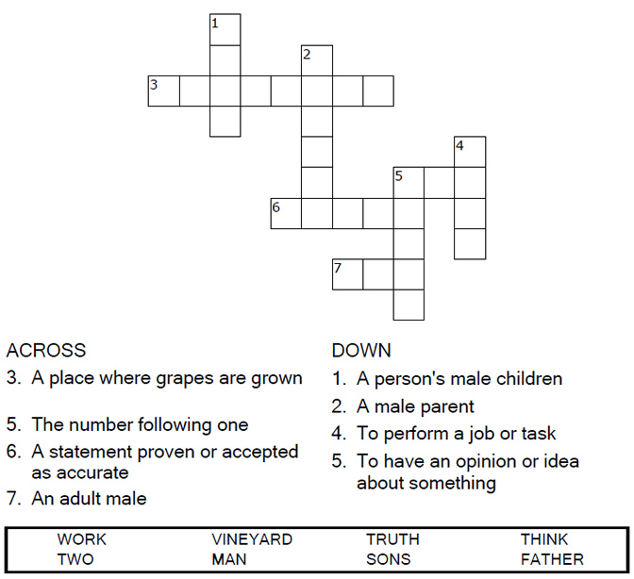


Copyright © Sermons4Kids, Inc.
May be reproduced for Ministry Use
Children’s Worship Bulletin

Parable of the Two Sons

Matthew 21:28-32

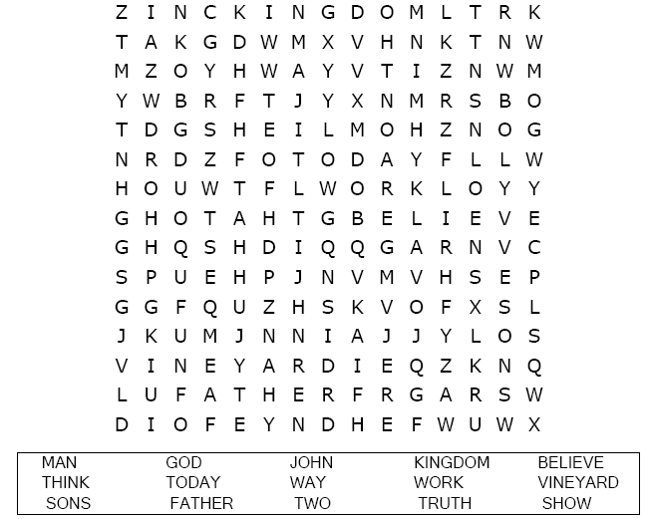

Faith United Methodist Church

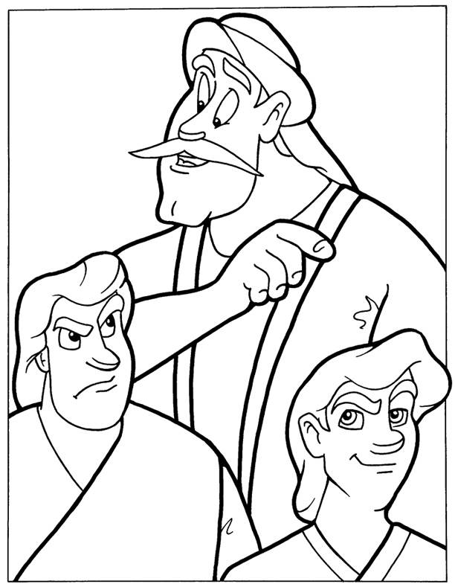
The Parable of the Two Sons
Matthew 21:28-30
Copyright © CalvaryCurriculum.com
Used by Permission

Each number represents a letter of the alphabet. Substitute
the correct letter for the numbers to reveal the coded words.

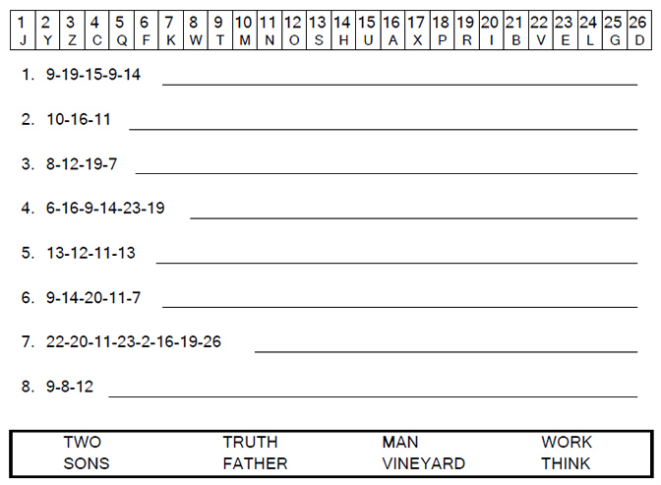

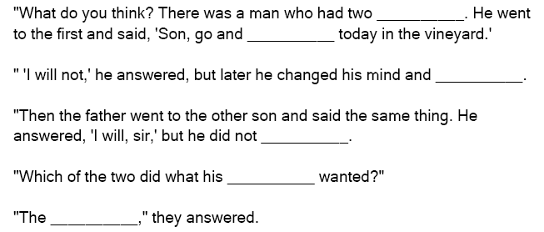

You can find the answers in Matthew 21:28-30 (NIV)

