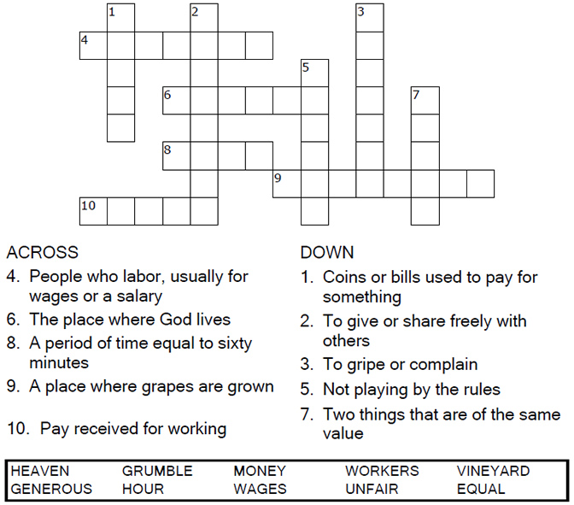
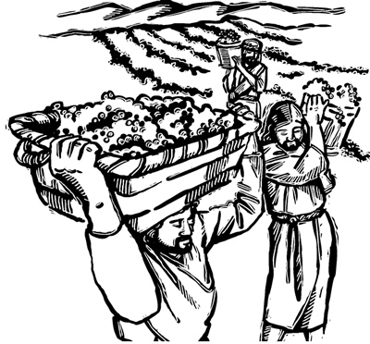

Copyright © Sermons4Kids, Inc.
May be reproduced for Ministry Use
Children’s Worship Bulletin

Workers in the Vineyard

Matthew 20:1-16

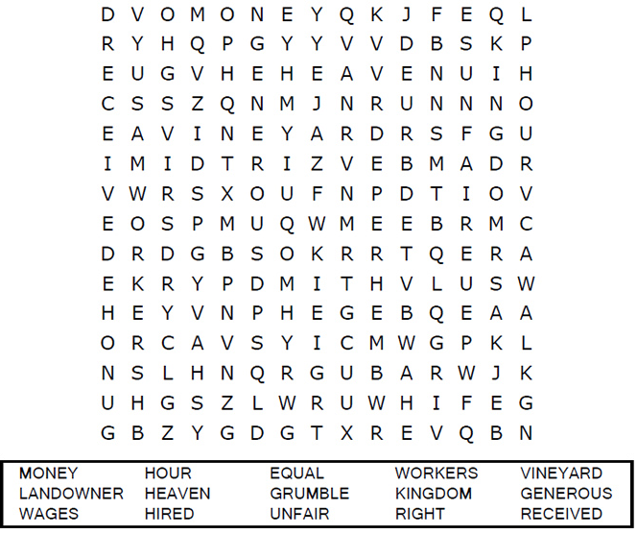
Faith United Methodist Church

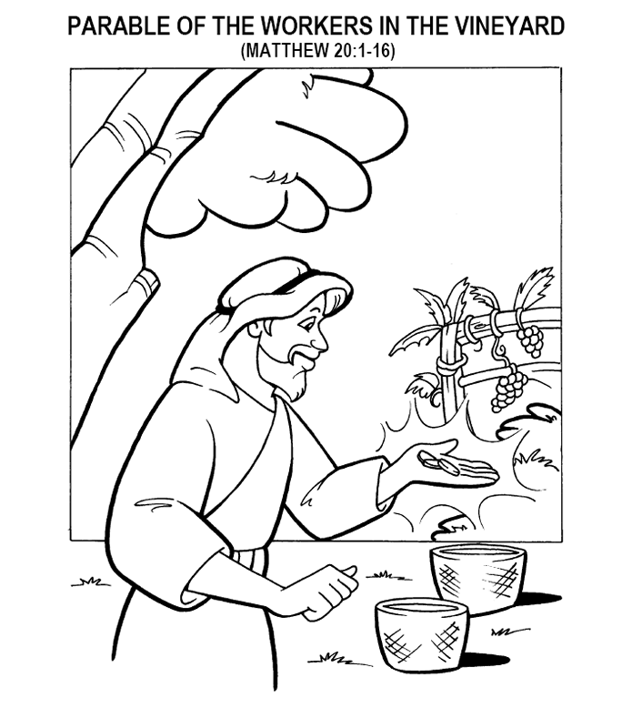
'These men who were hired last worked only one hour,' they said, '
and you have made them equal to us who have borne the
burden of the work and the heat of the day.'
Matthew 20:12
Copyright © CalvaryCurriculum.com
Used by Permission

Each number represents a letter of the alphabet. Substitute
the correct letter for the numbers to reveal the coded words.

